25Q4 DOM Based Injection Test

Introduction:

This penetration testing engagement was conducted to evaluate the security posture of the target application with a specific focus on identifying weaknesses related to DOM-Based Injection and other client-side vulnerabilities. The assessment aimed to determine whether user-supplied input could influence the application's client-side logic in a manner that results in unauthorized DOM manipulation or execution of arbitrary JavaScript within the user’s browser.
DOM-Based Injection represents a class of client-side security issues that arise when JavaScript processes Untrusted data—such as URL parameters, fragment identifiers, or browser storage—and incorporates it into the Document Object Model (DOM) without adequate validation or sanitization. These vulnerabilities are often overlooked because they do not rely on server-side processing; however, they can result in severe security impacts, including session compromise, data exposure, redirection, and full client-side code execution.
The testing process included a combination of manual analysis and automated tooling to identify unsafe data flows between DOM sources and sensitive sinks. The objective was to assess the application's resilience against client-side manipulation, evaluate the effectiveness of existing security controls, and provide actionable recommendations to mitigate identified risks

Table of Contents
Introduction: 2
25Q4 DOM Based Injection Test 4

25Q4 DOM Based Injection Test
Description

A DOM-Based Injection vulnerability can only occur when several interdependent conditions are met. The application must read attacker-controlled data from a DOM source (e.g., URL parameters or hash fragments) and pass it into an unsafe DOM sink (such as innerHTML or eval()) through client-side JavaScript. All these conditions must be present in the same data flow for the vulnerability to be exploitable. If any element of this chain is missing, DOM-Based Injection cannot occur.

A DOM-based injection only occurs if the entire chain is complete:

Attacker input → DOM Source → JavaScript Processing → DOM Sink → Code Execution

How the conditions relate

Condition 1 - There must be a DOM source

The application reads user-controllable data - (e.g., location.search, location.hash).

Condition 2 - There must be a DOM sink

The application writes data to dangerous location (e.g., innerHTML, eval()).

Condition 3 - Data must flow from source to sink

The source must directly or indirectly reach the sink through JavaScript

Condition 4 - The attacker must control the data

The attacker can manipulate the source (by Crafting malicious URL)

Test for Condition 1 - Check the application for DOM Source

Identify where the application reads the user controllable data from

1.Inspect application and Java Script Code that reads from the following

- location.search (query parameters)
- location.hash (fragment identifier)
- location.pathname
- document.URL / document.documentURI
- document.referrer
- localStorage / sessionStorage
- window.name
- postMessage events

- Analyse the browser sources tab manually for the parameters. Table below gives data regarding the parameter found in the application

Refer to the screenshot below for supporting evidence

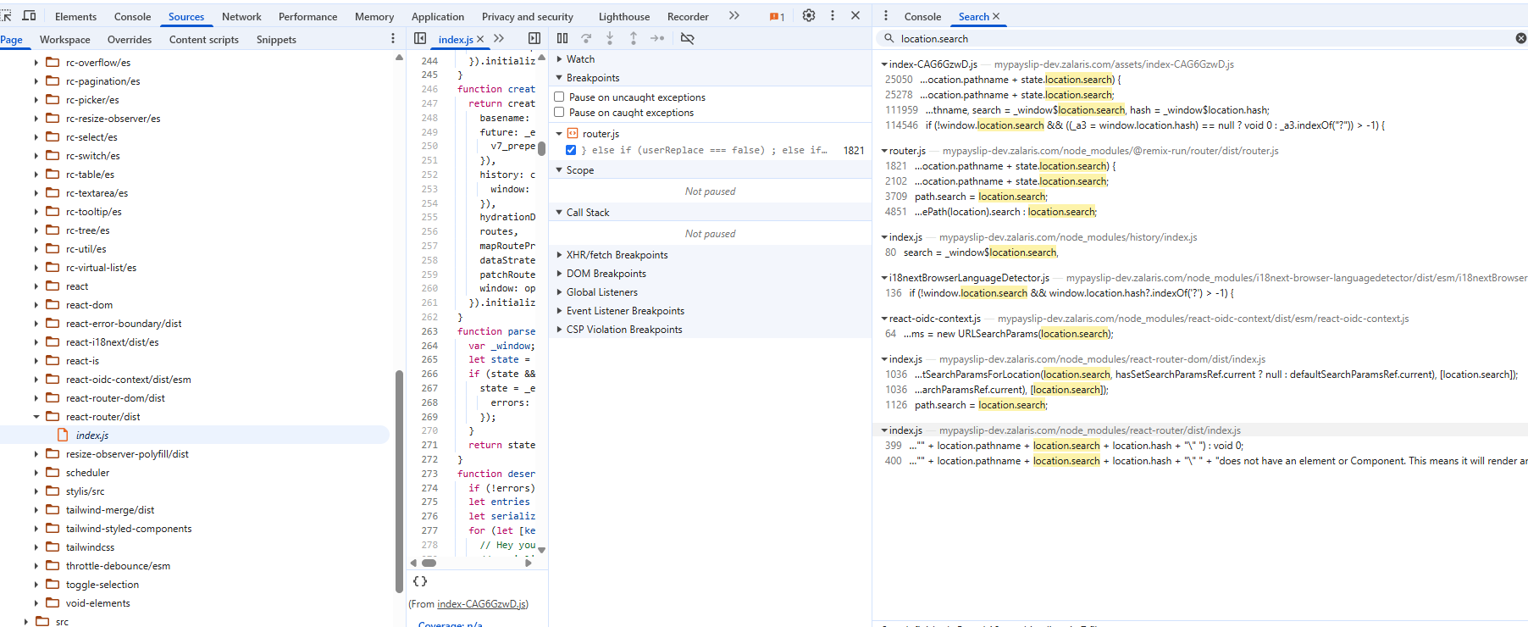

Location.Search

Found in the following paths

https://mypayslip-dev.zalaris.com/assets/index-CAG6GzwD.js

Line number - 25050 , 25278 , 111959 , 114546

https://mypayslip-dev.zalaris.com/node_modules/@remix-run/router/dist/router.js

Line number - 1821 , 2102 , 3709 , 4851

https://mypayslip-dev.zalaris.com/node_modules/history/index.js

Line number - 80

https://mypayslip-dev.zalaris.com/node_modules/i18next-browser-languagedetector/dist/esm/i18nextBrowserLanguageDetector.js

Line number - 136

https://mypayslip-dev.zalaris.com/node_modules/react-oidc-context/dist/esm/react-oidc-context.js

Line number - 64

https://mypayslip-dev.zalaris.com/node_modules/react-router-dom/dist/index.js

Line number - 1036 , 1036 , 1126

https://mypayslip-dev.zalaris.com/node_modules/react-router/dist/index.js

Line number - 399 , 400

Location.hash

Refer to the screenshot below for supporting evidence

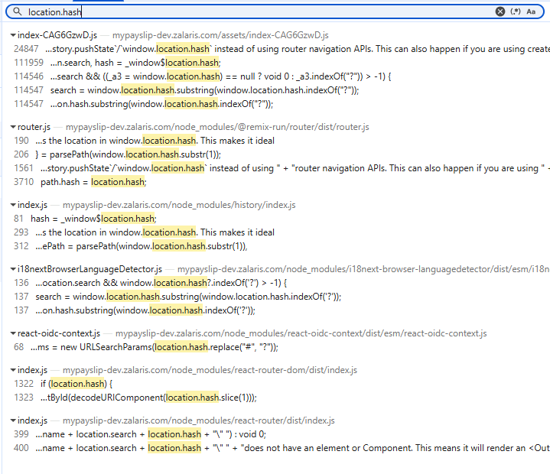

Found in the following paths

https://mypayslip-dev.zalaris.com/assets/index-CAG6GzwD.js

Line Number - 24847 , 111949 , 114546 , 114547, 114547

https://mypayslip-dev.zalaris.com/node_modules/@remix-run/router/dist/router.js

Line number - 190, 206, 1561, 3710

https://mypayslip-dev.zalaris.com/node_modules/history/index.js

Line Number - 81,293, 312

https://mypayslip-dev.zalaris.com/node_modules/i18next-browser-languagedetector/dist/esm/i18nextBrowserLanguageDetector.js

Line Number - 136 , 137 , 137

https://mypayslip-dev.zalaris.com/node_modules/react-oidc-context/dist/esm/react-oidc-context.js

Line Number - 68

https://mypayslip-dev.zalaris.com/node_modules/react-router-dom/dist/index.js

Line Number - 1322 , 1323

https://mypayslip-dev.zalaris.com/node_modules/react-router/dist/index.js

Line Number - 399 , 400

Location.pathname

Refer to screenshot below for supporting evidence

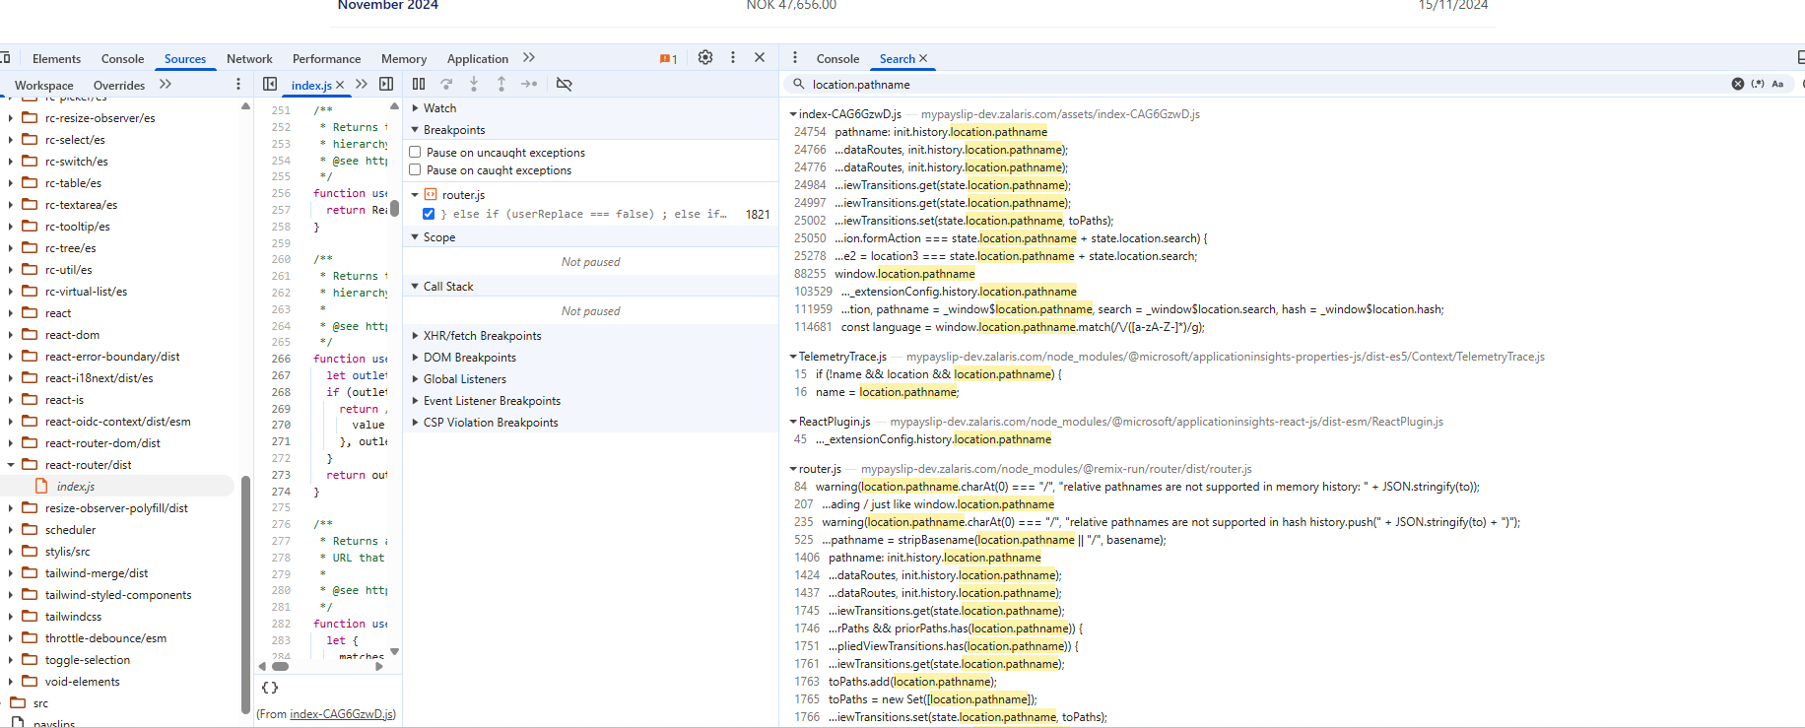

The parameter is found in the following paths

https://mypayslip-dev.zalaris.com/assets/index-CAG6GzwD.js

Line number - 24754 , 24766 , 24776 , 24984 , 24997 , 25002 , 25050 , 25278 , 88255 , 103529 , 11959 , 114681

https://mypayslip-dev.zalaris.com/node_modules/@microsoft/applicationinsights-properties-js/dist-es5/TelemetryContext.js

Line number - 15 , 16

https://mypayslip-dev.zalaris.com/node_modules/@microsoft/applicationinsights-react-js/dist-esm/ReactPlugin.js

Line number - 45

https://mypayslip-dev.zalaris.com/node_modules/@remix-run/router/dist/router.js

Line number -84 ,207 , 235 , 525 , 1406 , 1424 , 1437 , 1745 , 1746 , 1751 , 1761 , 1763 , 1765 , 1766 , 1821 , 1922 , 1932 , 2041 , 2060 , 2080 , 2102 , 2170 , 2189 , 3334 , 3410 , 3416 , 3422 , 3702 , 3704

https://mypayslip-dev.zalaris.com/node_modules/history/index.js

Line number - 79 , 162 , 423 , 469 , 498 , 581 , 600 , 634 , 651

https://mypayslip-dev.zalaris.com/node_modules/react-router-dom/dist/index.js

Line number - 836 , 837 , 1304 , 1304 , 1438 , 1439

https://mypayslip-dev.zalaris.com/node_modules/react-router/dist/index.js

Line number - 374 , 383 , 399 , 400 , 859 , 862

https://mypayslip-dev.zalaris.com/src/authConfig.ts

Line number - 17

No Instances of Document.URL / document.URL found
No Instances of document.referrer found
No Instances of window.name found

LocalStorage

Found at the following locations

https://mypayslip-dev.zalaris.com/assets/index-CAG6GzwD.js

Line number - 8103 , 8229 , 19322 , 19326 , 19329 , 19330 , 19331 , 19344 , 19366 , 19373 , 19376 , 19377 , 19378 , 19380 , 19382 , 19383 , 19388 ….

https://mypayslip-dev.zalaris.com/node_modules/@microsoft/applicationinsights-common/dist-es5/Enums.js

Line Number- 9

https://mypayslip-dev.zalaris.com/node_modules/@microsoft/applicationinsights-common/dist-es5/StorageHelperFuncs.js

Line Number- 10 , 14 , 17 , 18 , 19 , 24 , 25 , 35 , 35 , 63 , 73 , 77 …..

https://mypayslip-dev.zalaris.com/node_modules/@microsoft/applicationinsights-common/dist-es5/ThrottleMgr.js

Line number - 7 , 13 , 16 , 37 , 39 , 124 …..

https://mypayslip-dev.zalaris.com/node_modules/@microsoft/applicationinsights-common/dist-es5/applicationinsights-common.js

Line number 31

https://mypayslip-dev.zalaris.com/node_modules/@microsoft/applicationinsights-properties-js/dist-es5/Context/Session.js

Line number 8 , 96 , 144 , 145, 174

https://mypayslip-dev.zalaris.com/node_modules/i18next-browser-languagedetector/dist/esm/i18nextBrowserLanguageDetector.js

Line number 155 , 156 , 157 …..

https://mypayslip-dev.zalaris.com/node_modules/oidc-client-ts/dist/esm/oidc-client-ts.js

Line number - 890 , 1018

https://mypayslip-dev.zalaris.com/node_modules/react-router-dom/dist/index.js

Line number - 1340 , 1362

https://mypayslip-dev.zalaris.com/src/components/payslips-page/PayslipsView.tsx

Line number - 30 , 34

SessionStorage

Found in the following Paths

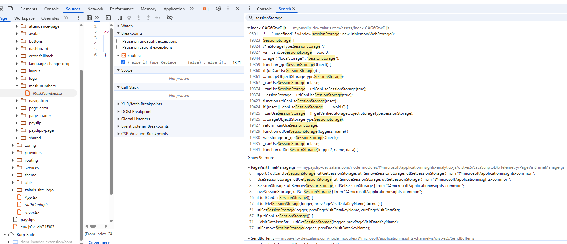

https://mypayslip-dev.zalaris.com/assets/index-CAG6GzwD.js

Line number - 9591, 19323 …..

https://mypayslip-dev.zalaris.com/node_modules/@microsoft/applicationinsights-analytics-js/dist-es5/JavaScriptSDK/Telemetry/PageVisitTimeManager.js

Line number - 8 , 46 , 47 , 51 , 67 , 71 , 77

https://mypayslip-dev.zalaris.com/node_modules/@microsoft/applicationinsights-channel-js/dist-es5/SendBuffer.js
Line number - 7 , 76 , 80 , 131, 132 , 139

https://mypayslip-dev.zalaris.com/node_modules/@microsoft/applicationinsights-channel-js/dist-es5/Sender.js

Line number - 8 , 12 , 39

https://mypayslip-dev.zalaris.com/node_modules/@microsoft/applicationinsights-channel-js/dist-es5/__DynamicConstants.js

Line Number - 53

https://mypayslip-dev.zalaris.com/node_modules/@microsoft/applicationinsights-common/dist-es5/Enums.js

Line number - 10

https://mypayslip-dev.zalaris.com/node_modules/@microsoft/applicationinsights-common/dist-es5/StorageHelperFuncs.js

Line number -11 …

https://mypayslip-dev.zalaris.com/node_modules/@microsoft/applicationinsights-common/dist-es5/applicationinsights-common.js

Line Number -…

https://mypayslip-dev.zalaris.com/node_modules/@remix-run/router/dist/router.js

Line number 1496

https://mypayslip-dev.zalaris.com/node_modules/i18next-browser-languagedetector/dist/esm/i18nextBrowserLanguageDetector.js

Line number 191 ….

https://mypayslip-dev.zalaris.com/node_modules/oidc-client-ts/dist/esm/oidc-client-ts.js

Line number 2415

https://mypayslip-dev.zalaris.com/node_modules/react-router/dist/index.js

Line number - 1280 , 1282 , 1291

https://mypayslip-dev.zalaris.com/src/components/mask-numbers/MaskNumber.tsx

Line number - 3

Windo.name

No Instances were found in the path

postMessage Events

Found in the following paths

https://mypayslip-dev.zalaris.com/assets/index-CAG6GzwD.js

Line number 534, 7789 , 9520 , 43874

https://mypayslip-dev.zalaris.com/node_modules/axios/lib/utils.js

Line number -691, 696 , 705 , 710

https://mypayslip-dev.zalaris.com/node_modules/oidc-client-ts/dist/esm/oidc-client-ts.js

Line number - 565 , 2342

https://mypayslip-dev.zalaris.com/node_modules/rc-overflow/es/hooks/channelUpdate.js

Line number 10

https://mypayslip-dev.zalaris.com/node_modules/scheduler/cjs/scheduler.production.min.js

Line number 14

DOM sinks

Analyse whether the following DOM Sinks are available in the source of the application

The list given below are high risk DOM sinks

eval()
new Function()
setTimeout(string)
setInterval(string)
document.write()
document.writeln()
window.location assignment (if string concatenation)
location.href = …
window.open(...)

No instances for the above DOM sinks are present

Look for HTML Injection Sinks

The following sinks must be present

innerHTML
outerHTML
insertAdjacentHTML
Document.body.innerHTML
Document.body.outerHTML

Refer the screenshot below for available instances of innerHTML

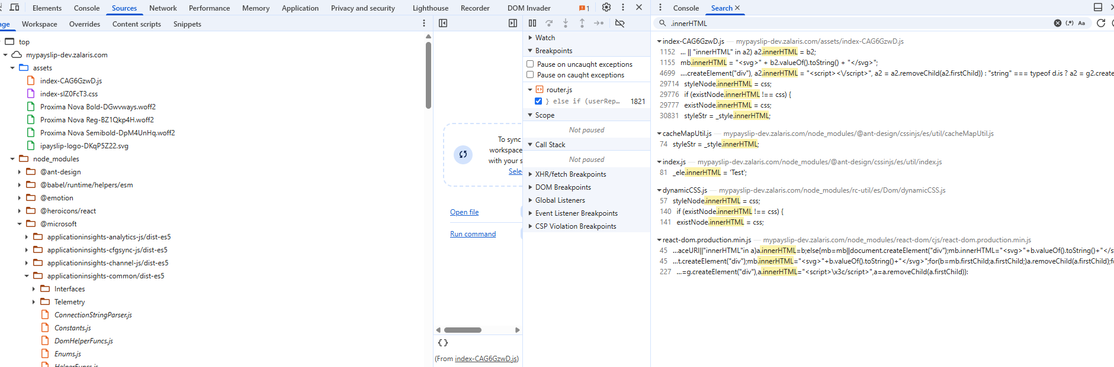

No instances of outerHTML are present

No instances of insertAdjacentHTML()

No instances of document.body.innerHTML

No instances of document.body.outerHTML

Look for DOM Attribute Manipulation Sinks

Instances of elements.setAttribute()

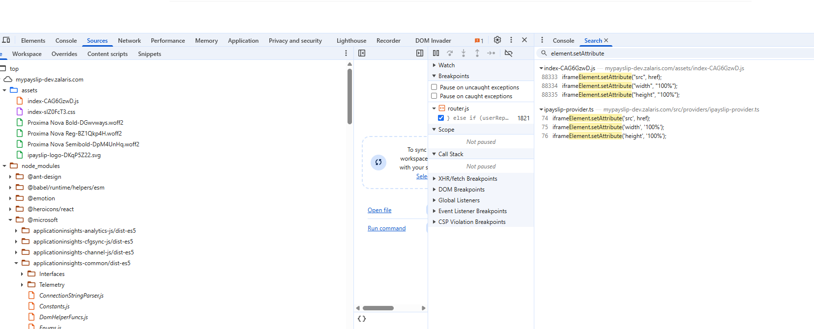

Instances of element[name]

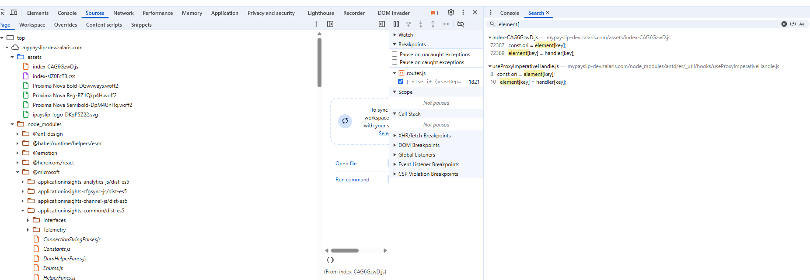

JQuery Based Sinks

Look for the following JQuery based sinks

.html()
.append()
.prepend()
.after()
.before()
.replaceWith()
.prop()
.attr()

No Instances of .html() available

Refer screens-shots attached below for the JQuery based sinks available

Instances of .append() available
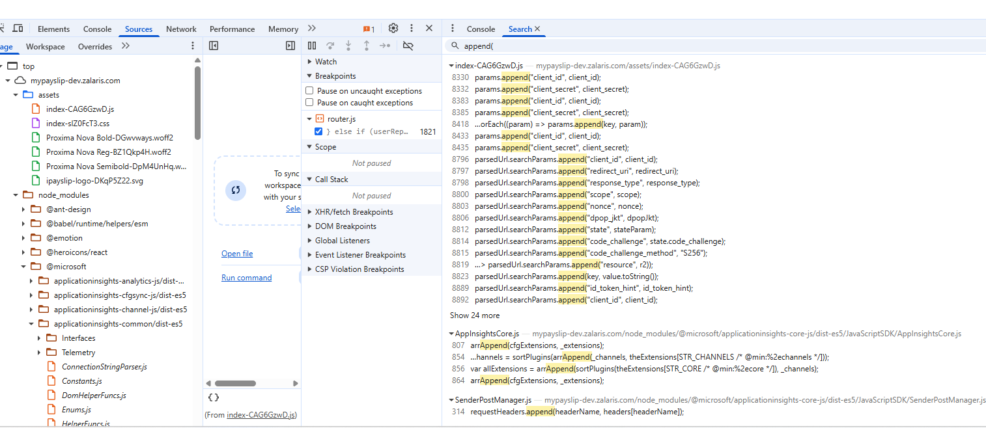

Instances of .after()

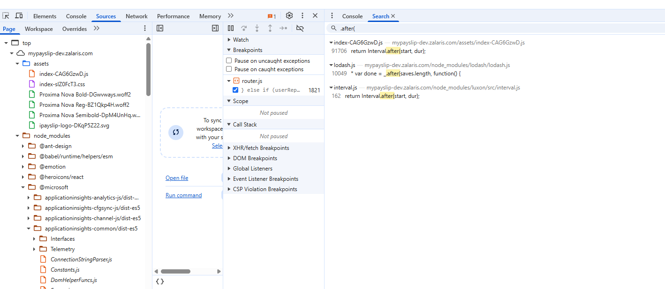

Instances of .before()

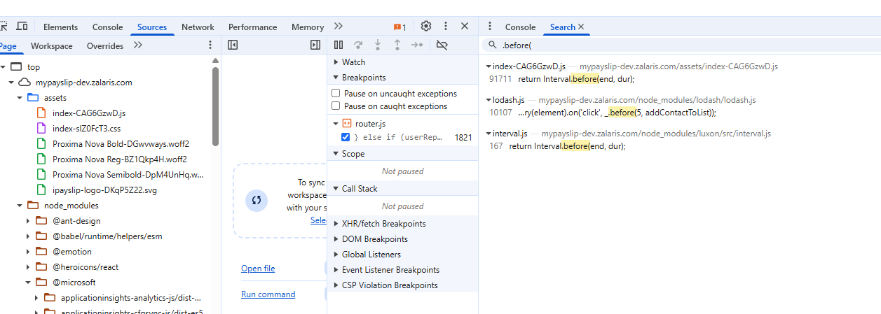

No Instances of replaceWith() is available

No Instances of prop() and attr() available

Analysis of flow between source and sink

Setup breakpoints in the application and look for flow in the application

A DOM sink is the actual point where your input becomes dangerous.

If you break at the sink, you can see:

- Whether your injected value actually reaches the sink
- Whether there's any encoding/escaping done
- Whether sanitization libraries (e.g., DOMPurify) modify it
- The full call stack showing how it got there
- The original tainted value (from hash, query param, etc.)

The sink parameters in that are available in the application are given below

- innerHTML()
- setAttribute()
- element[
- .append()
- .after()
- .before()

Set breakpoints at all the sinks and analyse the inputs passed on to the

The upstream process leads to the source from where the function was called

A general upstream flow is given below

SINK ← handling function ← processing function ← SOURCE

Analyse the web developer tools Local Tab for the sink values passed onto from the source

Refer to screenshot below for supporting evidence

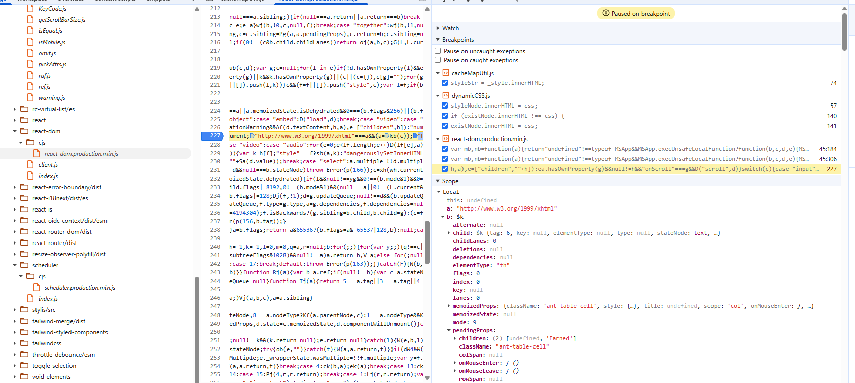

The following value is being passed on from the source to sink

- http://www.w3.org/1999/xhtml

WORKLOG

When | What | Who | Recommended Action
19 November 2025 | DOM Based injection Test against https://mypayslip-dev.zalaris.com test in progress | Mohammed Sharoz

